

Facial Recognition with Thermal Screening



June 21, 2020

VDEFINE

Table of Contents

**Facial Recognition with Thermal Screening** 2

**Why this idea over other ideas:** 2

**What is Facial Recognition with Thermal Screening?** 2

**Application Flow:** 2

**Facial Detection and Recognition:** 4

**Thermal Screening:** 5

**Future Enhancements:** 7

# **Facial Recognition with Thermal Screening**

‘Covid-19'... has become a buzz word these days. Coronavirus spreads from touching the infected surface and finger [biometric](https://cio.economictimes.indiatimes.com/tag/biometric) system requires to put a finger on the surface of the biometric attendance system. We have to understand how offices get infected by the spread of viruses and bacteria to contain the spread in offices thus we could achieve a more hygienic and productive [workplace](https://cio.economictimes.indiatimes.com/tag/workplace). So, we come up with an alternative to track the attendance as well as the body temperature.

## **Why this idea over other ideas:**

There are several other ways to track attendance. For example, scanning Id Card. As there are chances of misusing the card like some other person can use it and we don’t have an option to track body temperature with that. So, the best alternative to biometric system would be ‘Facial Recognition with Thermal Screening ' to track the attendance.

## **What is Facial Recognition with Thermal Screening?**

A facial recognition system is a technology capable of identifying or verifying a person from a digital image or a video frame from a video source. This system is to mark the attendance.

Thermal screening will allow to detect body temperature.

Our idea is to develop a system with both Facial Recognition and Thermal Screening.

## **Application Flow:**

Firstly, we have to register the employee and we have to train the system for facial recognition by capturing the employee photo

When an employee comes to the entrance, screening process starts.

The system will recognize the employee then Emp details along with the body temperature tracked by the system will be displayed. If the temperature is normal i.e., 98F then the attendance will be marked. If the temperature is abnormal then the mail will be sent to HR and Employee.

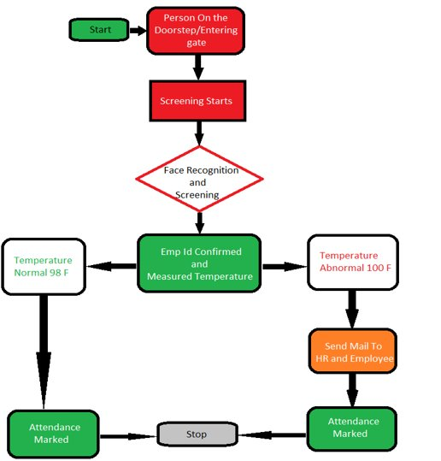

## **Facial Detection and Recognition:**

Facial detection and recognition can be achieved in many ways in the current world. Initially, we have planned to go for husky lens (an Artificial Intelligence Camera) which would cost us around 6k. but however due to this pandemic, since we have less options available with us, we were unable to get the husky lens. Then we thought to go with next available less expensive options and we have finally decided to achieve the same purpose using webcam.

We are going to use JavaCV a wrapper of OpenCV (Open Source Computer Vision Library is an open source computer vision and machine learning software library) to achieve the facial detection and recognition

* **Technology Used:**

Core Java, JavaCV (wrapper of Opencv ), JavaFX, MySQL, Maven

## **Thermal Screening:**

Most of the temperature measurement techniques around the world require some sort of physical contact between the temperature sensor and the object or environment whose temperature is to be measured, but as technology advanced, this changed too. The need to be able to measure the temperature of an object without physical contact arose. This need brought the measurement of temperature using infrared sensors.

The principle of operation of Infrared thermometers is simple, all bodies at a temperature above 0 Kelvin (absolute zero) emit an infrared energy which can be detected by the infrared thermometer sensor. It’s design includes a lens that focuses the infrared energy being emitted by the object in front of a detector. The detector converts the energy into an electrical signal which then can be passed to a microcontroller to interpret and display in units of temperature after compensating for the variation in ambient temperature.

The following components are required to build this project:

* [MLX90614 IR SENSOR](http://goo.gl/E6mYkP)
* [Arduino Uno](http://educ8s.tv/part/ArduinoUno)

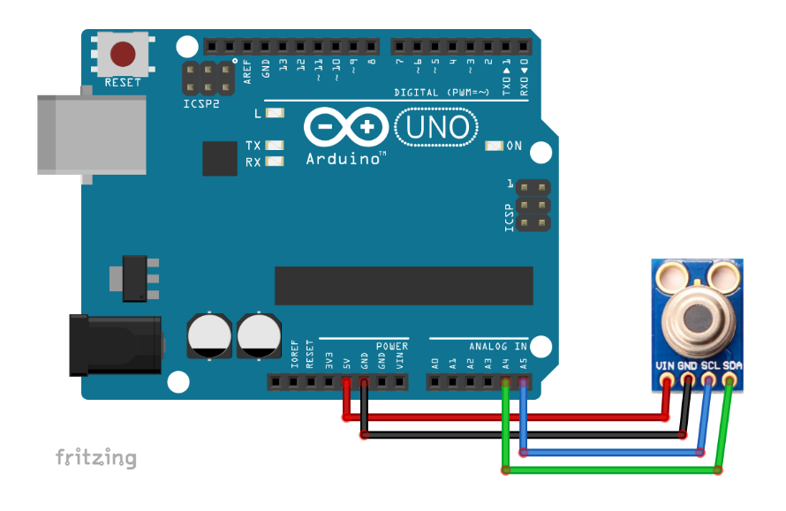

Here is some information about the MLX 90614 sensor:

* Range for ambient temperature: -40 to 125 ˚C (-40 to 257 °F)
* Range for object temperature (non-contact): -70 to 380 ˚C (-94 to 716 °F)

Accuracy: 0.5°C for (0-50 °C) both ambient and object

The **object temperature** is the non-contact measurement you'd expect from the sensor, while the **ambient temperature** measures the temperature on the die of the sensor.

To enable us to communicate easily with the sensor[,](https://github.com/adafruit/Adafruit-MLX90614-Library) we will use the mlx90614 temperature sensor library from Adafruit using Arduino IDE

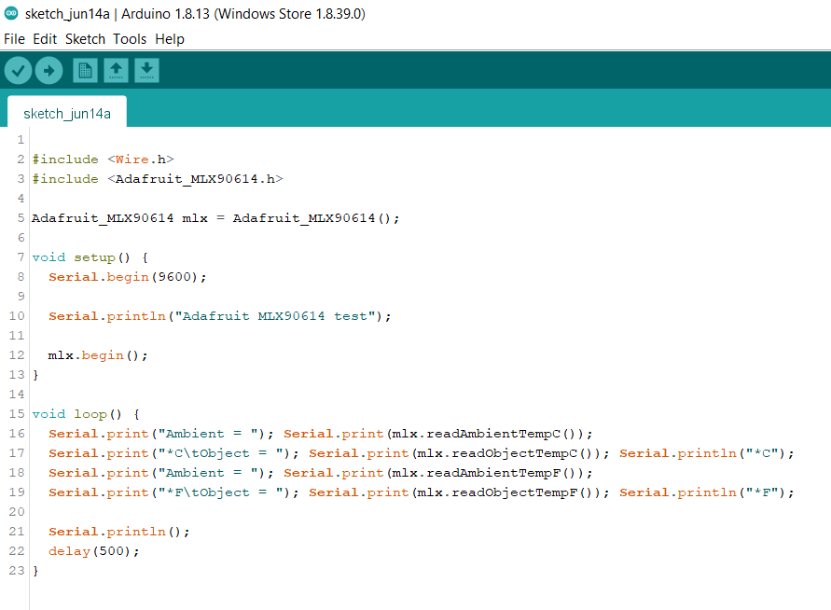

## **Future Enhancements:**

We are going to have the following enhancements for future implementation:

* Once the identity is confirmed, the employee should sanitize his hands.
* Once the sanitization is completed the system will detect for mask. If the mask was not detected then the employee access will be denied. Else his access will be granted and attendance will be marked.

